

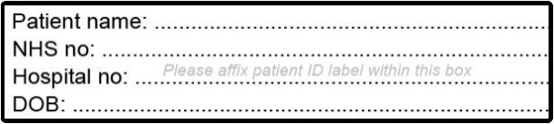
Consent for Podiatry A&G

using NHS Electronic Referral

Statement of the patient
I have had the process of Podiatry Diabetic Foot and photography explained to me and I have had the opportunity to ask questions. I understand that:
- Advice & Guidance is not always a substitute for seeing a hospital consultant.
- there may be a difference between the accuracy of clinical care using photographs as compared to face-to-face clinical assessment
- the accuracy of the advice given to my GP may be limited by the system
- the photographs will be securely stored with in the NHS electronic referral system
- the photographs may be temporarily stored on a mobile device until they are transferred to the NHS electronic referral system
- the photographs will not be used for any other purpose without seeking additional consent
- I have the right to withhold or withdraw my consent to podiatry, following which any images related to me will be deleted, at any time without this affecting my right to future care or treatment
I consent to photographs being taken which will form part of my health records □
The Podiatry department may use patient images to teach other health care professionals, to improve the quality of foot care you may receive in the future. Please tick below if you are happy for your images to be used in this way.
I agree to my image(s) being used for teaching Health Care Professionals □

Name: …………………………………………………..Date:………DD/MM/YYYY …….

Signature: ……………………………………………………………………………….........

A witness should sign below if the patient is unable to sign but has indicated their consent. A parent / guardian should sign on behalf of children.

Name: …………………………………………………..Date:………DD/MM/YYYY …….

Signature…………………………………………..Relation to patient………………........

Statement of healthcare professional
I have discussed the advice and guidance service with the patient and provided them with the opportunity to ask questions.
If using a mobile photographic device I have discussed the reasons for taking clinical photos using a mobile device, and how the images will be used, transmitted and stored, and have explained the inherent risks and benefits. I understand the risks of data transfer from a mobile device and have taken appropriate steps to mitigate these risks.

Name: …………………………………………………..Date:………DD/MM/YYYY …….

Signature: ………………………………………………Role……………………………….

