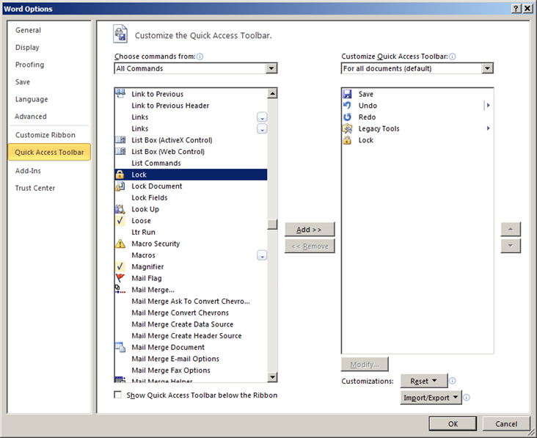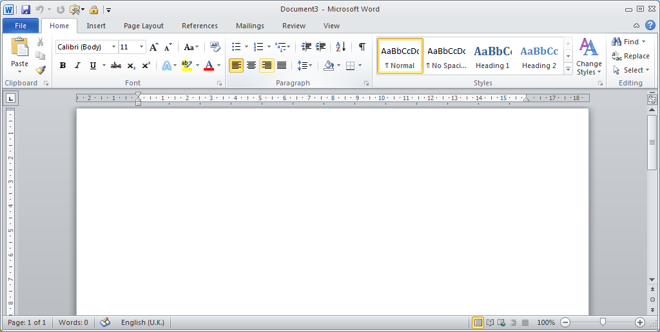

**Removing Protection from documents to enable you to tick boxes by clicking on the padlock icon** [https://encrypted-tbn0.gstatic.com/images?q=tbn:ANd9GcSBfkDZA_jEi8YSve3l9FQM6dwFhAFKrdkSmkIz8WHX_8aaWSLGVfqZS1w](http://www.google.co.uk/url?url=http://www.softicons.com/toolbar-icons/soft-scraps-icons-by-deleket/button-play-icon&rct=j&frm=1&q=&esrc=s&sa=U&ei=X1BLVfuwNKTj7QaZuYDIAw&ved=0CCgQ9QEwCTgU&usg=AFQjCNEeKW-3F34rNDd9nJZ0TcJoGH-cug)

First customise your Quick Access Toolbar to include the Padlock icon [https://encrypted-tbn0.gstatic.com/images?q=tbn:ANd9GcSBfkDZA_jEi8YSve3l9FQM6dwFhAFKrdkSmkIz8WHX_8aaWSLGVfqZS1w](http://www.google.co.uk/url?url=http://www.softicons.com/toolbar-icons/soft-scraps-icons-by-deleket/button-play-icon&rct=j&frm=1&q=&esrc=s&sa=U&ei=X1BLVfuwNKTj7QaZuYDIAw&ved=0CCgQ9QEwCTgU&usg=AFQjCNEeKW-3F34rNDd9nJZ0TcJoGH-cug). The Quick Access Toolbar is a customizable toolbar that contains a set of commands that are independent of the tab on the Ribbon that is currently displayed. You can move the Quick Access Toolbar from one of the two possible locations, and you can add buttons that represent commands to the Quick Access Toolbar.

Click Customize Quick Access Toolbar Button image.and select More Commands

Select “Choose commands from box,” pick All Commands. Scroll down until you find the padlock under Lock. Click on Add to send across to your Customizations. Click OK

.