How to import/receive new referral templates for Systmone (S1) from DRSS

Import with pre-filled merge fields:

Download the proforma from the Formulary Website / DRSS Bulletin.
Save the file to your desktop / shared drive area.

In SystmOne go to Setup > Referrals & Letters > New Word Letter Templates

Click import templates
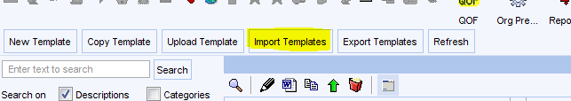

Navigate to the file you have downloaded and saved.
Click Open.

Import without the merge fields:
Download the file from the Formulary Website / DRSS Bulletin.
Save the file to your desktop / shared drive area.

In SystmOne go to Setup > Referrals & Letters > New Word Letter Templates
Click New Template
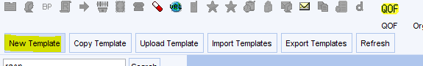

Click Import an existing Word document
Click OK
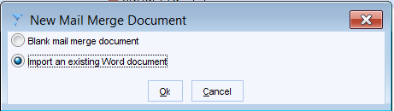

Navigate to the file you have downloaded / saved
Click open

Add in the merge fields as you normally would.

