How to Import Referral templates into Emis Web

1. Creating a Folder on your Desktop:
- Right click on your desktop and select ‘New’ followed by ‘Folder’. Please title the new folder ‘Templates’.
2. Download referral templates from E-mail or from link to a website.
- Open the email/link containing the templates.
- Right click on the attachment containing the template and select ‘Save as’.
- Navigate to the folder titled ‘Data Entry Templates’ on your desktop and select ‘Save’

3. Access Template Manager from the home page of EMIS WEB
- In the navigation pane, click the Document Templates tab.

- Select the folder where you want to save the imported template or create a new one.

On the Template Manager ribbon, click Import.

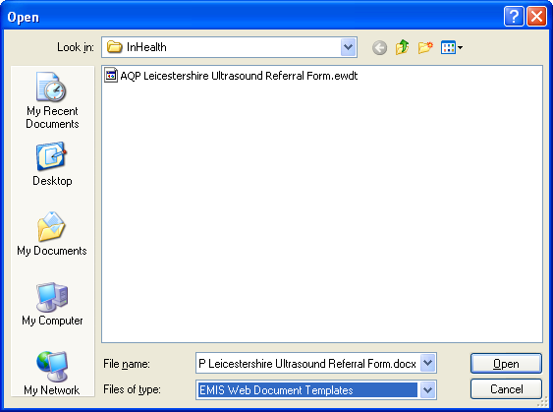
- The Import Template screen is displayed.

- Navigate to the location of the required template, and then click Open.

The template is imported to the selected folder.

PLEASE REMEMBER TO DEACTIVATE PREVIOUS VERSION OF THE SAME TEMPLATE PRIOR TO INSTALLING THE LATEST VERSION.

